Everyday Safety
Tailgate Talks
How To Hold A Tailgate Talk
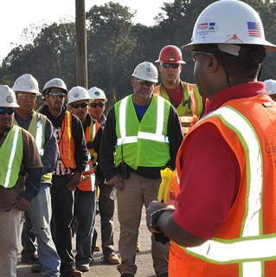
Tailgate (or Toolbox) talks are short informational meetings held with employees to discuss a worksite related safety topic. The term tailgate meetings comes from the practice of meeting around the tailgate of a pickup truck on the job site. The goal of hosting tailgate talks is to inform employees of specific hazards associated with a task and discussing the safe way to do a job. Tailgate talks also serve as a reminder to employees of what they already know while establishing the supervisor’s credibility and conscientiousness about his or her responsibilities for safety.
Here are some tips for running a successful tailgate talk:
- Keep them brief. 10 to 15 minutes is an ideal amount of time for a tailgate talk.
- Keep them specific. Tailgate meetings must address specific hazards, or safe workplace practices that relate to the job and/or work the employees are actually performing.
- The meetings should draw on the experience of employees and utilize that experience to remind them of the dangers of particular construction processes, tools, equipment, and materials.
- Always give workers an opportunity to ask questions at the end of the toolbox talk. Don’t make snide remarks to employees who do ask a question, as this will discouraging others from asking questions later.
- The meetings should be informal and periodic on an as-needed basis.
- Keep a short record of what topic was discussed, when, and which employees were present so you can avoid repetition and maximize the impact of the talks.
- Practice what you preach. Nothing makes a trainer lose credibility faster than to have a worker see them doing something that violates the safety precautions that were covered in a previous toolbox talk. Always set a good example.
- Remember to always just KISS (Keep it Simple for Safety)

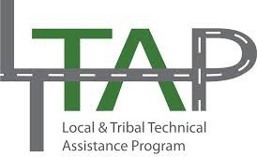

Everyday Safety Tailgate Talks are published by the Cornell Local Roads Program in cooperation with the National Local Technical Assistance Association and participating partner organizations.

Resources and References:
For a list of sample tailgate talks provided by NYSDOT visit www.dot.ny.gov/main/business-center/contractors/construction-division/safety-health- information/tailgate-safety-talks
OSHA Toolbox Talks URL
http://www.oshatraining.com/Toolbox-Talks.php
A sample sign in sheet is available on page 3 of this document.

Date: / /

Sign In Sheet:

Name: Signature:

